Overdale Community Primary School – Nursery Autumn Term 1 2023
Theme: Who am I?
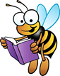  Specific Area: Literacy  Focus Texts – ‘Hug’ ‘You choose’  Talk for writing text- Mr Wiggle, Mr Waggle’  Phonics- This half-term we will be focusing on listening and attention activities  alongside tuning into environmental and instrumental sounds. Activities about how to support at home will be posted on Dojo’s on week 3 and 6.  We will be providing opportunities for children to recognise their name in a variety of ways. Some children will be ready to practise writing the letters in their name.  We will be using Talk for Writing to develop our story telling and to create our own stories  We will also be learning and exploring a variety of nursery rhymes and stories focusing on specific vocabulary to support the children’s developing speech and understanding- We will be sharing these on Class Dojo each week |  | 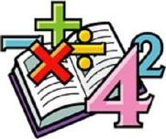  Specific Area: Mathematics  Number-sense  We will be learning a variety of counting nursery rhymes which we will share on class  Dojo each week. These will support the children to learn to count to 5.  We will also be exploring the various board puzzles around the classroom and learning about  shapes by matching resources to their silhouette in the provision.  The children will learn to recognise patterns in the classroom by looking for stripes, spots and zigzags on clothes furniture etc. Help us at home by spotting patterns you see outside and in the house.  We will explore the composition of numbers by splitting objects into unequal parts and putting them back together again. You can practise this in many ways at home and begin to use mathematical language e.g. ‘so you can put the big part of the banana and the little part of the banana back together again.  As part of our Word Aware we will also be exploring position language such as in front, next to, behind etc. Support us at home by discussing these concepts in practical ways e.g. comparing your family’s hands/ feet. Talking about where objects are e.g. ‘The bird is on top of the house’
Specific Area: Knowledge and Understanding of the World  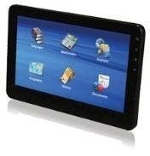  We will be practising using an iPad to take photographs and to open QR codes to read books and access educational apps  We will be looking at similarities and differences between people and their lifestyles, including how we can celebrate differences  We will be learning about different festivals around the world  We will be exploring our body and our senses  We will be discussing people that are important to us  We will be exploring daily routines  We will be asking on Dojo’s for photos of the children now and when they were babies to add to our display. Look out for these on weeks 2 and 4. | Ourselves  BIG QUESTION  Who am I – what makes me, me? |  | Specific Area: Personal and Social Development (PSED)  We will be learning about ourselves and others, including things about us that are similar and things that are different  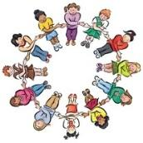  We will think about what makes us special and what our own strengths are  We will talk about those people that are important to us and think about the value of our relationships  We will identify and name parts of our bodies  We will discuss zones of regulation to support children in recognising different emotions  We will also be exploring our school and class values
Specific Area: Physical Development  This half term we will be focusing on the movements we can make with our bodies  We will learn about how we can look after our bodies, including healthy  habits and eating  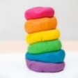  We will be taking part in daily doh-disco activities where we will learn  the finger family and learning the key moves- We will also be sharing  this with you at home so the children can practise at home!  We will also be practising our scissor and pencil grip in a variety of ways | Prime Area: Communication and  Language  We will be focusing on our speaking and listening skills – taking turns to speak and listening to each other  We will also be learning and using key vocabulary related to our theme.  This will be shared with you at home  so you can support your child to use and understand language. |  | Specific Area: Expressive Arts and Design Music  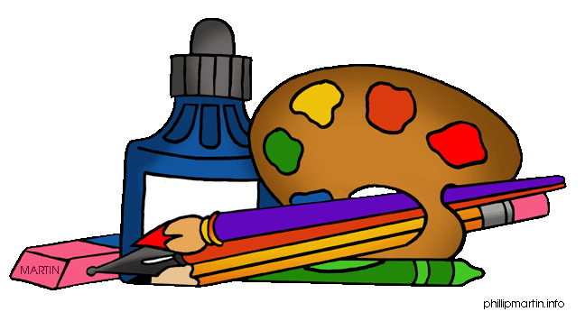  This half term we are going to be focusing on portraits  We will be exploring colour, texture and shape through collage and painting  We will be learning simple rhymes and songs about ourselves and our bodies  We will be involved in everyday role-play involving familiar routines at school and at home

Reading - Children will be expected to read their home reading books at least three times a week with a written comment from a parent in their reading record. Books will be changed once a week, but your child’s book bag needs to be in school every day please – thank you for your support
Dojo profiles – Please remember to send us photos and videos of what your child is doing at home – anything from walking the dog, swimming, playing in the play park, baking etc – we can’t wait to see your photos

